Local DNS Attack Lab

NAME: JASHWANTH REDDY GANGULA

SUID: 646254141

**1. Lab Overview**  
We will first setup a DNS Server, and then try various farming attacks on the target within the lab environment. This lab only focuses on the local DNS attacks.

**2. Lab Environment**

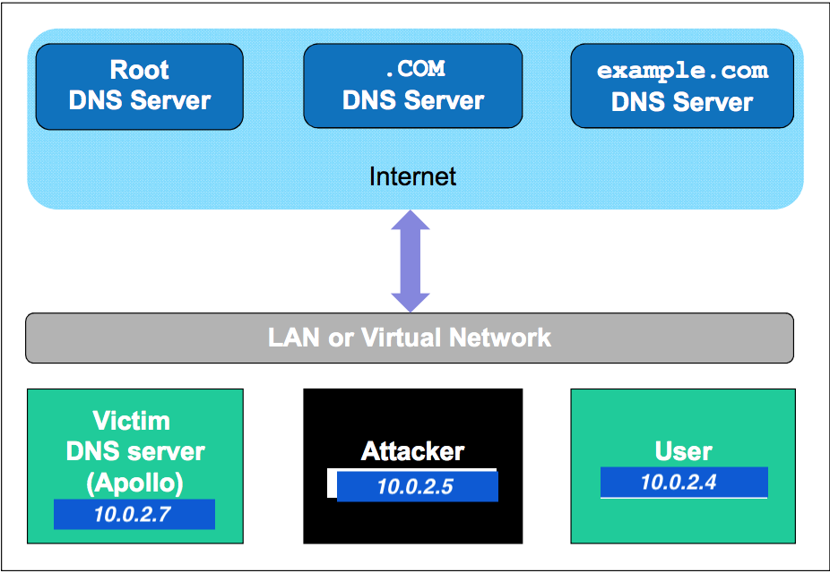

We setup the DNS server, Attacker and User on the same LAN environment. In the current lab, the IP addresses of DNS is 10.0.2.7, the Attacker machine’s IP is 10.0.2.5, the User machine’s IP is 10.0.2.4.

**2.1 Install and configure the DNS server**

Step 1: Install the DNS server using the command “sudo apt-get install bind9”. On our VM it is already installed as show in the image below.

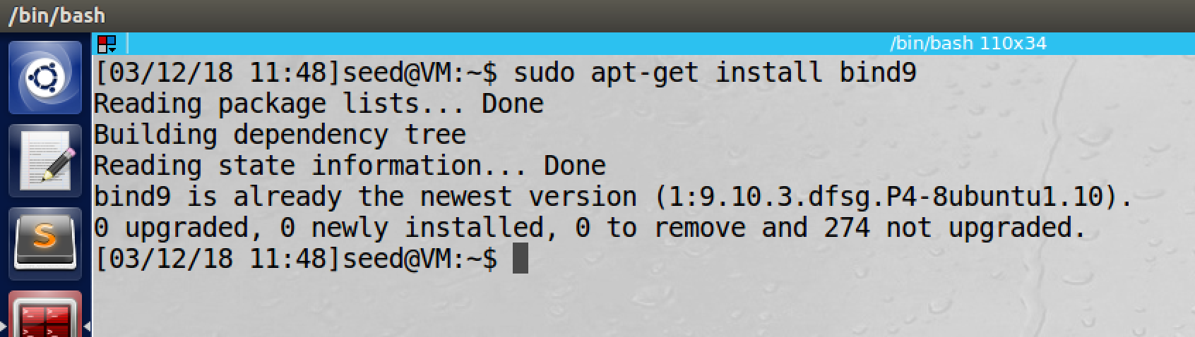

Step 2: Create the named.conf.options file.  
The DNS server needs to read the /etc/bind/named.conf configuration file to start. This configuration file includes an option file called /etc/bind/named.conf.options . We will add the following content to the option file. (The content was already added to the file in the setup.)

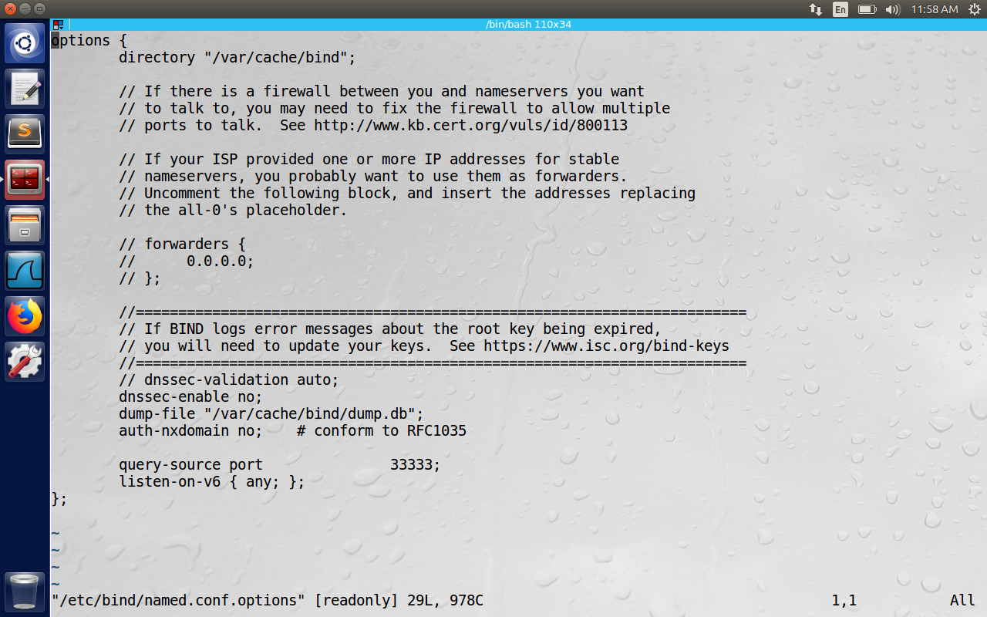

The file /var/cache/bind/dump.db is used to dump DNS server’s cache.

Step 3: Create zones.  
Assume we own a domain called “example.com”. We are responsible for providing definitive answers for regarding “example.com”. (We can use example.com because it is reserved for uses in documentation and hence safe.)

I have added the following information to the file “/etc/bind/named.conf.local”, The IP address range used in this setup is 10.0.2.0/24.

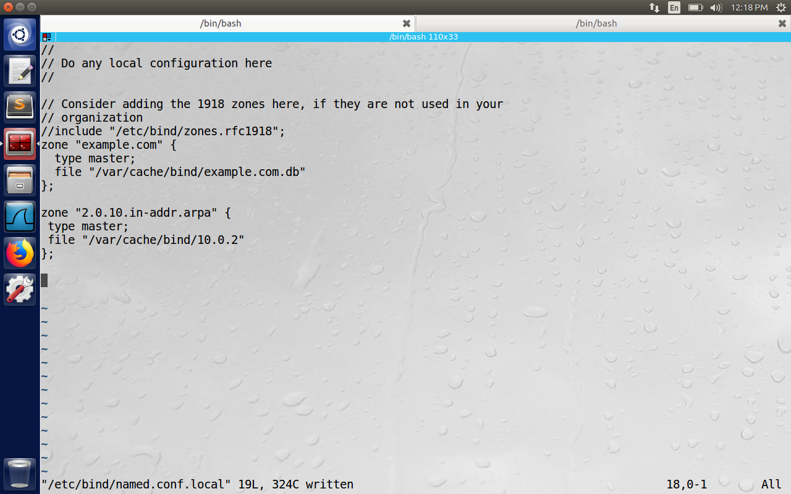

Step 4: Setup zone files

The file “/var/cache/bind/example.com.db” here is zone file. The actual DNS resolution is kept in this zone file. The content of file is as shown below. (2018031201 is today’s date +today’s serial number)  
The symbol ’@’ stands for example.com . ‘IN’ means internet, ‘SOA’ means start of authority, the zone file contains 7 records(RR),

1. a SOA RR

2. a NS(Name Server)RR

3.a MX(mail exchange) RR

4.4 A (host address) RRs

so total is 7 records

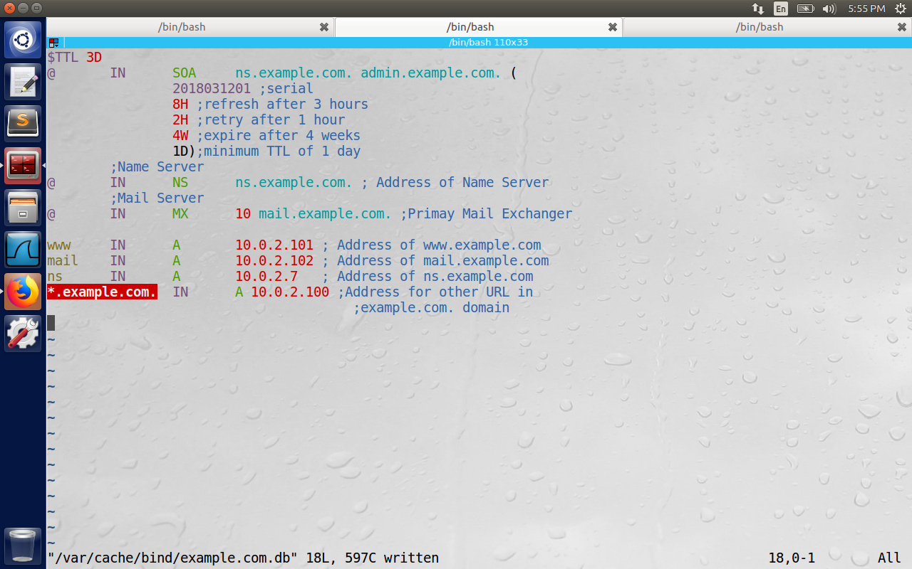

We also need to setup a reverse DNS lookup file. In the directory /var/cache/bind we compose a file with name “10.0.2” for example.com domain with the following content. (We observe the reverse mapping for www, mail, ns in the last three lines below.)

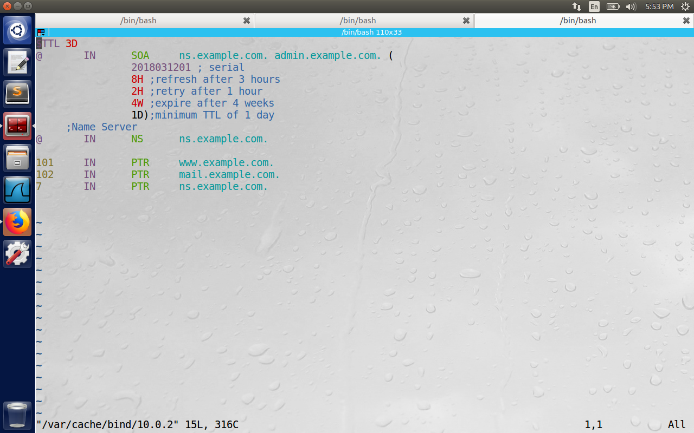

Step 5: Start a DNS Server

Use the command “sudo service bind9 restart” or “sudo /etc/init.d/bind9” to start the DNS service.

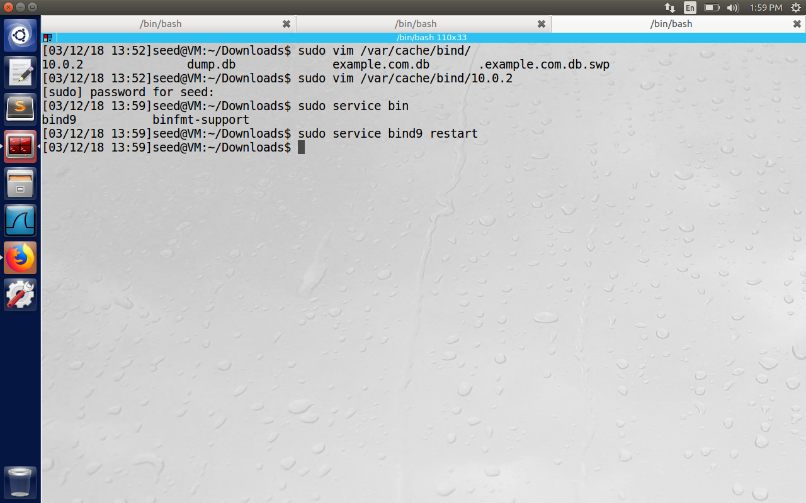

**2.2 Configure the User Machine**

On the user machine with IP 10.0.2.4, we need to let the machine with IP 10.0.2.7 be the default DNS server. We achieve this by changing the DNS setting file /etc/resolv.conf of the user machine. Here the file /etc/resolv.conf on the user machine is configured with the name server of DNS(i.e., 10.0.2.7 in our case and commented the third line below which is localhost)

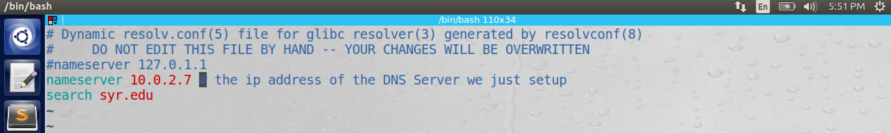

Now in Ubuntu, the file “/etc/resolv.conf” may be overwritten by DHCP client. To avoid this we need to tell the DHCP client not to set the DNS server automatically. For this we go to system settings->Network->Wired connection 1(in my case)->Ipv4 settings->Automatic(DHCP)addresses only, and configure the DNS server with 10.0.2.7 settings. Basically we tell the DHCP client to put the value we have typed in DNS servers to the file “/etc/resolv.conf”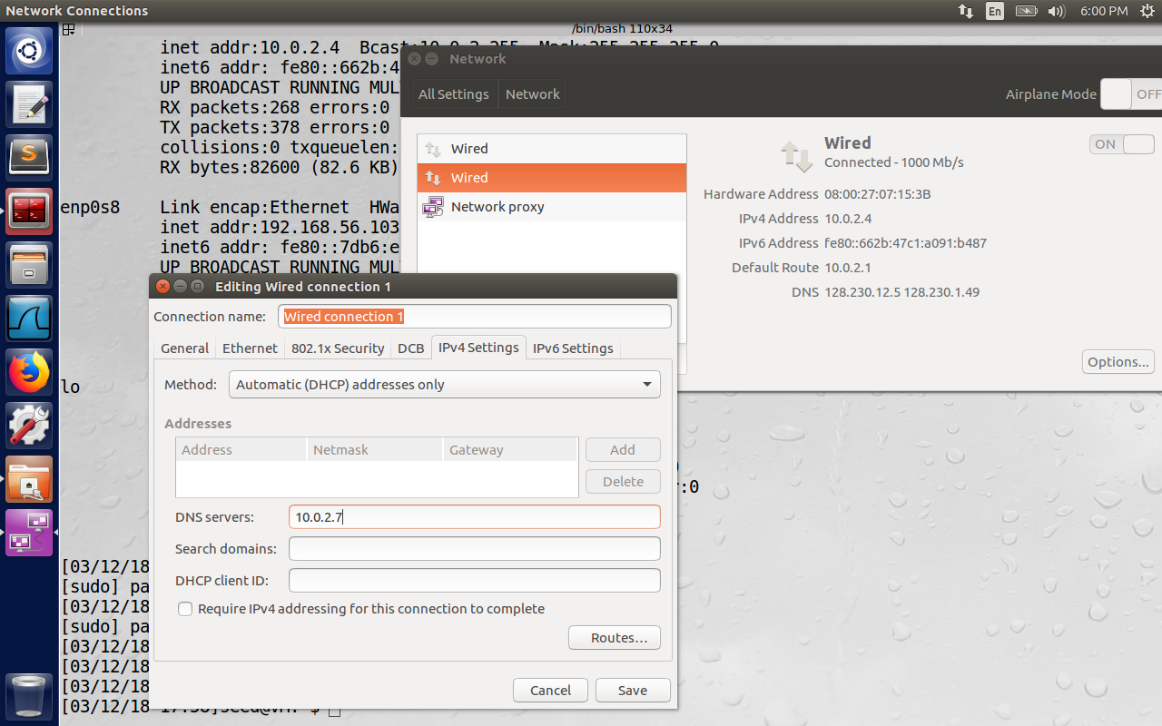

**2.3 Configure the Attacker Machine**

There is not much, to configure on the Attacker Machine. In our case, the attacker machine IP is 10.0.2.5

**2.4 Expected Output**

After we have setup the ab environment, our DNS server is ready to go. Now we issue the following command on the user machine: “dig [www.example.com](http://www.example.com)”. We see the below output.

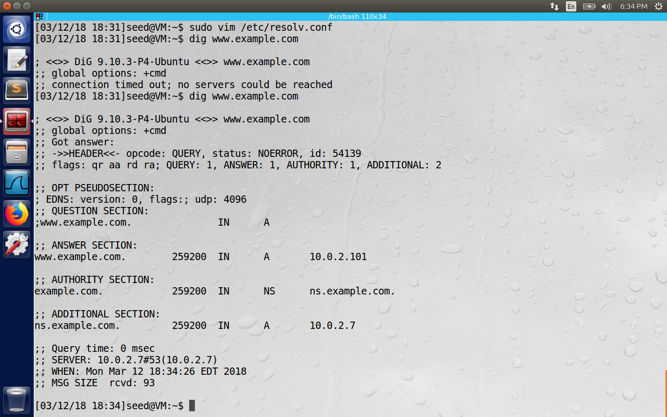

Here the ANSWER SECTION contains the DNS mappings. We can observe the IP address of [www.example.com](http://www.example.com) is now 10.0.2.101, which is what we have setup in the DNS server. For a simple and clean answer, we can use nslookup instead. Now we do a reverse DNS lookup using the command “dig –x 10.0.2.101”. The ANSWER SECTION contains the domain name as www.example.com

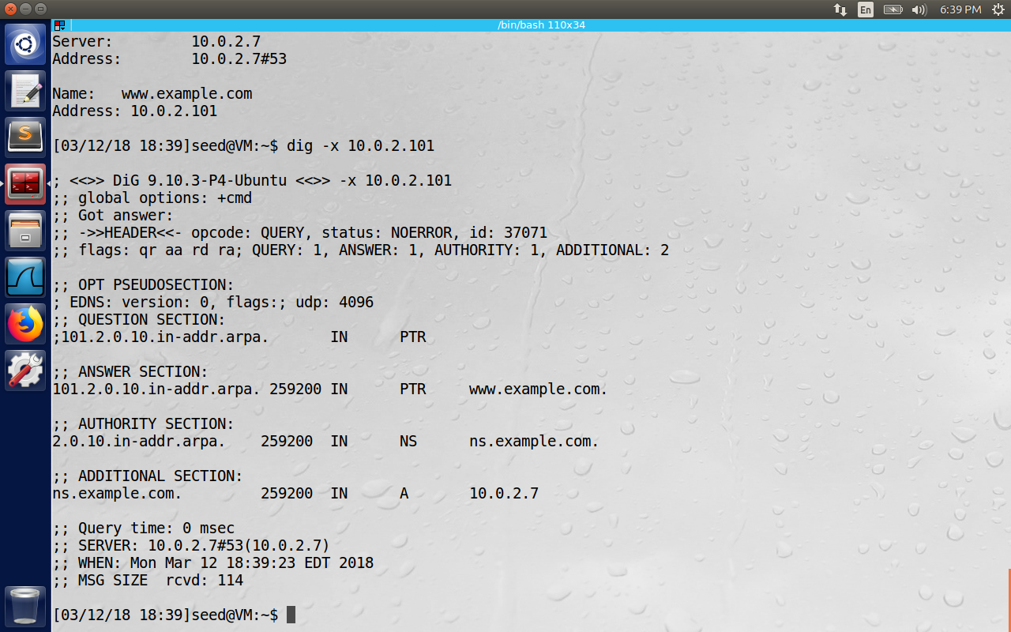

**2.5 Install Wireshark**

The Wireshark is already installed on the Virtual Machine, we can also use netwox sniffer tools, Wireshark is better for sniffing.

**3. Lab Tasks**

The main objective of Pharming Attack is to redirect the user to another Machine B, when the user tries to get to Machine A using its host name. In this lab, we will use [www.example.com](http://www.example.com) instead of real examples like [www.chase.com](http://www.chase.com), because example.com is reserved for documentation purposes. When the user types the [www.example.com](http://www.example.com) on his browser, the user’s machine will issue a DNS query to find the IP address of this website. Attacker’s goal is to fool the machine with fake DNS reply, which makes the user visit the malicious IP address.

**3.1 Task 1: Attackers have already compromised the victim’s machine**

**Modifying HOSTS file:** The hostnames and IP addresses pairs in the HOSTS files(/etc/hosts) are used for local lookup; they take preference over remote DNS lookups. We configure the [www.example.com](http://www.example.com) with the IP as 151.101.116.81(since the domain for this is <http://www.bbc.com> without need for https).

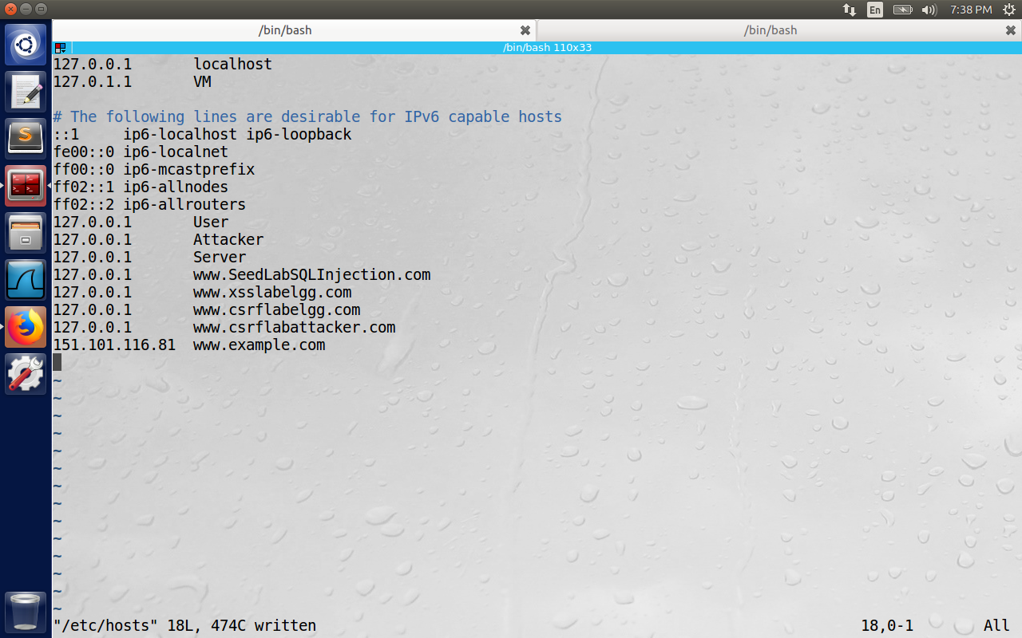

Here the ping command is used to demonstrate that we have redirected [www.example.com](http://www.example.com) to 151.101.116.81

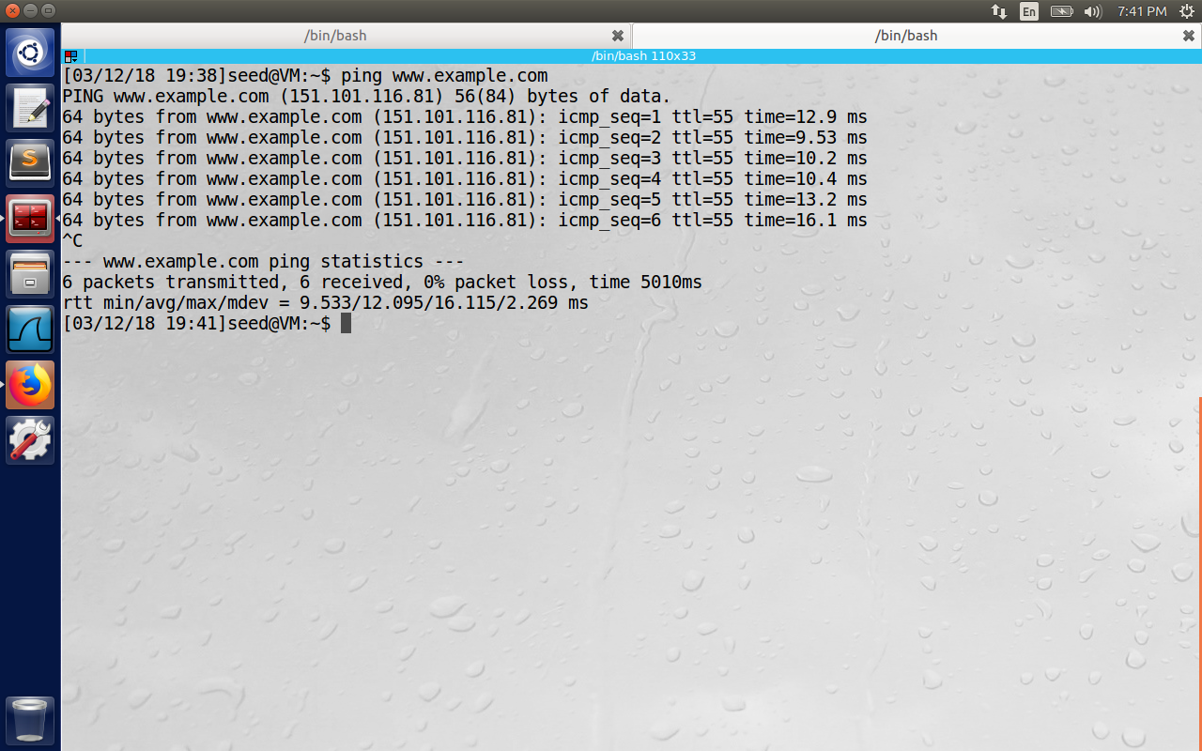

**3.2 Task 2: Directly Spoof Response to User**

The attacker has to meet the following criteria to spoof the DNS reply before the legitimate DNS Server sends the reply.

1. The Source IP address should match the IP address of the DNS server.

2. The destination IP address must match the IP address of the user’s machine.

3. The source port number (UDP port) must match the port number that the DNS request was sent to (usually port 53)

4.The destination port must match the port number that the DNS request was sent from.

5.The UDP checksum must be correctly calculated.

6.The transaction ID must match the transaction ID in the DNS request.

7.The domain name in the question of the reply must match the domain name in the question section of the request.

8.The domain name in the answer section must match the domain name in the question section of the DNS request.

9.The user’s computer must receive the attacker’s DNS reply before it receives the legitimate DNS response.

First we start the netwag tool on the attacker machine with IP as 10.0.2.5 with the command as sudo netwag 105 –hostname [www.example.com](http://www.example.com) --hostnameip “10.20.30.40” –authns “ns.example.com” –authnsip “10.20.30.50” –device “enp0s3” --ttl 300 –filter “src host 10.0.2.4”

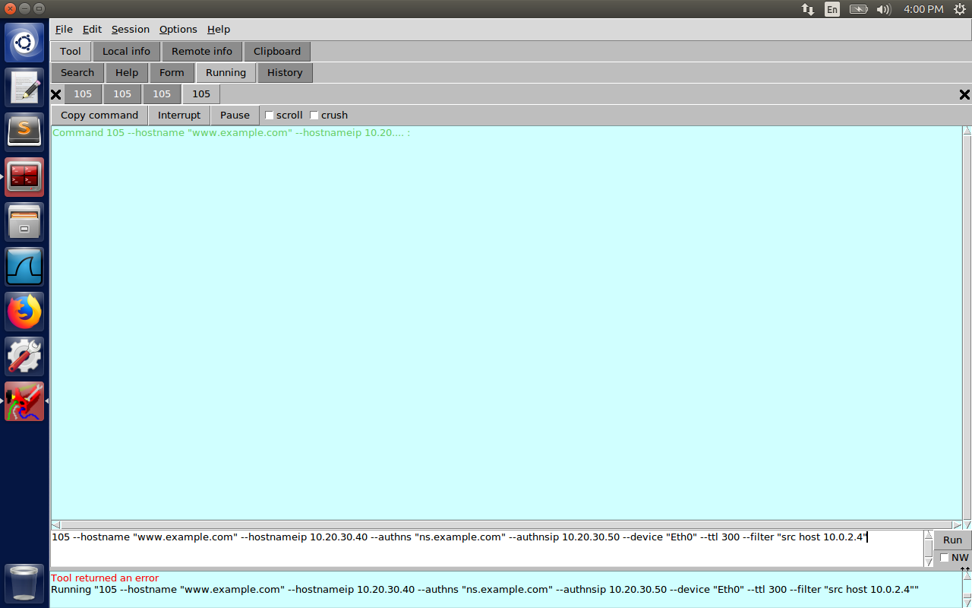

The attack is not successful now as the DNS server sends the reply before the attacker spoofs the fake DNS reply with the answer as 10.20.30.40 (and name server as 10.20.30.50).   
  
Please observe the answer to the client as 10.0.2.101 in the below figure.

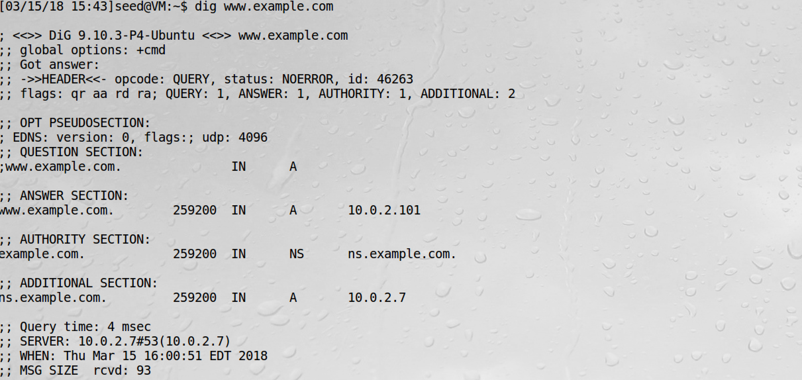

In the below figure the entry number 4 contains the DNS response with the answer as 10.0.2.101 as in the zone file configuration on the server. The reply from the attacker is also received on the entry number 7 with the answer record as 10.20.30.40, but it is discarded because it is late.

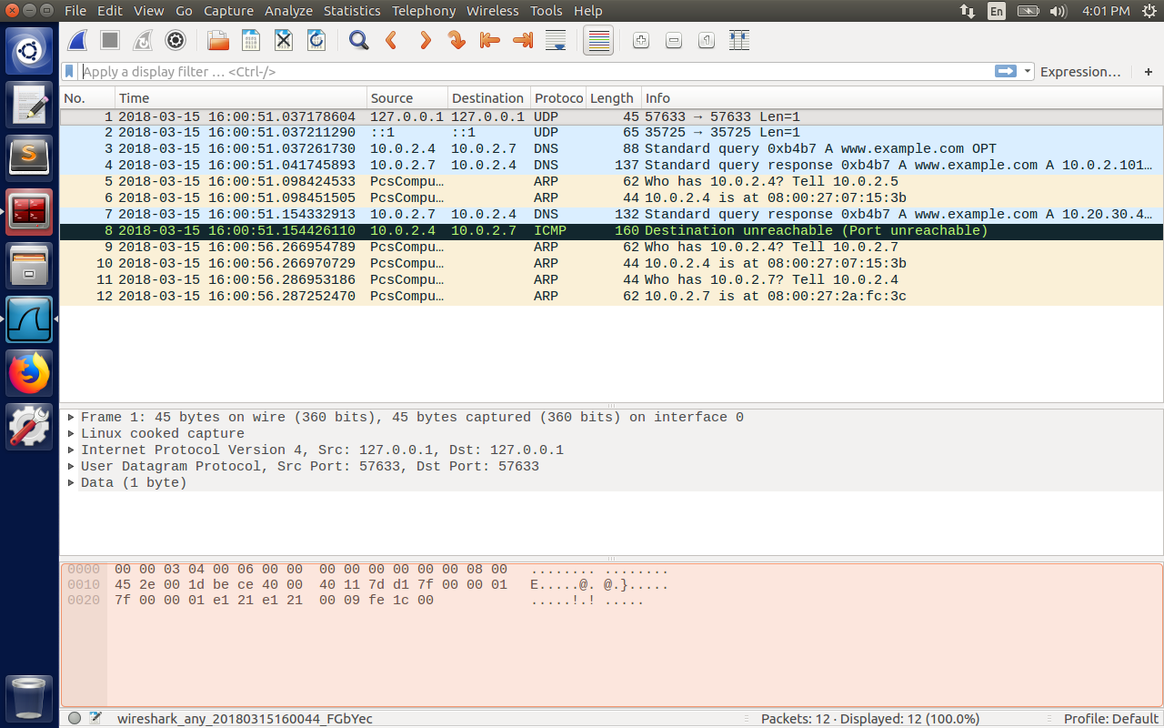

After some attempts the attack can be successful, but we have to clear the DNS cache on the server every time before the attack using the command “sudo rndc flush” and “sudo rndc dumpdb -cache”



Now the attack is successful as shown below. Here the answer is received from the attacker before the DNS server sends the reply. Hence the fake IP address of 10.20.30.40 (associated with www.example.com)is sent to the client.

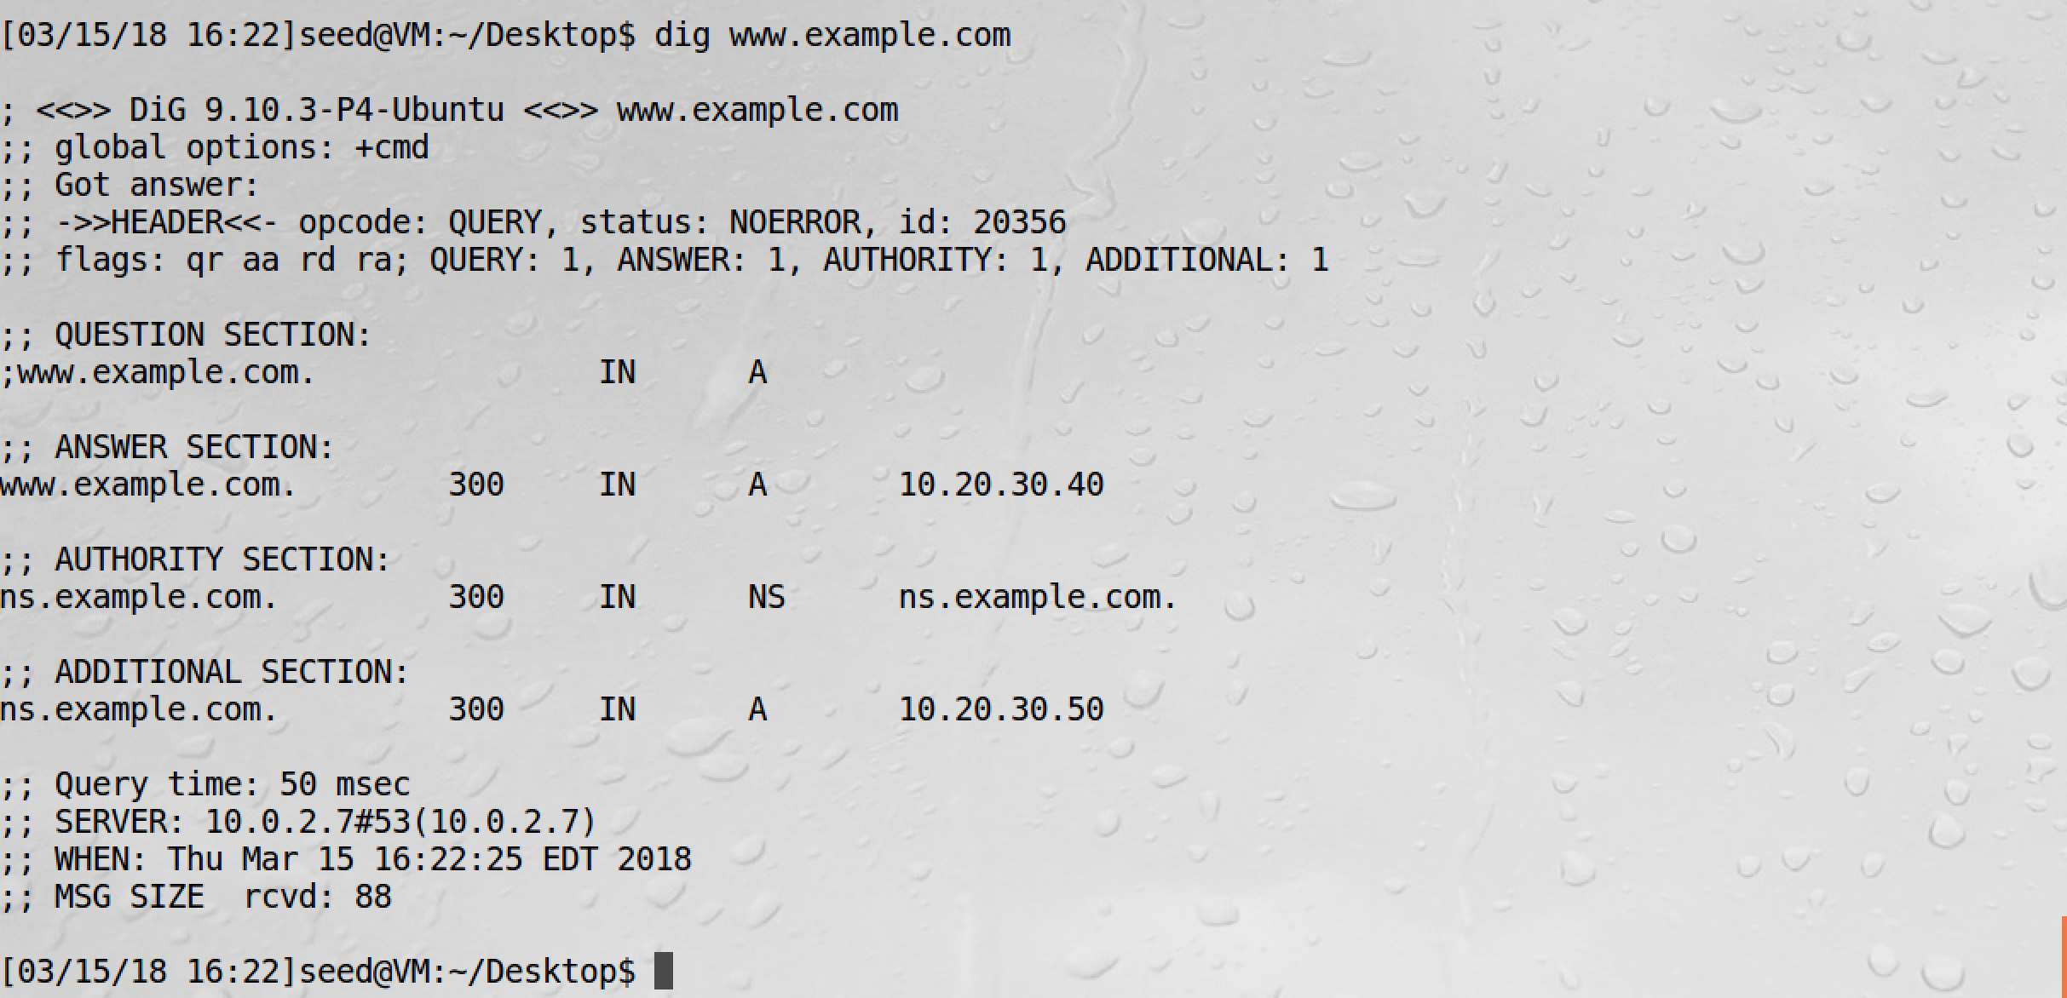

In the entry number 89 below, please observe the answer records as 10.20.30.40 for [www.example.com](http://www.example.com) and NS as 10.20.30.50 for ns.example.com.

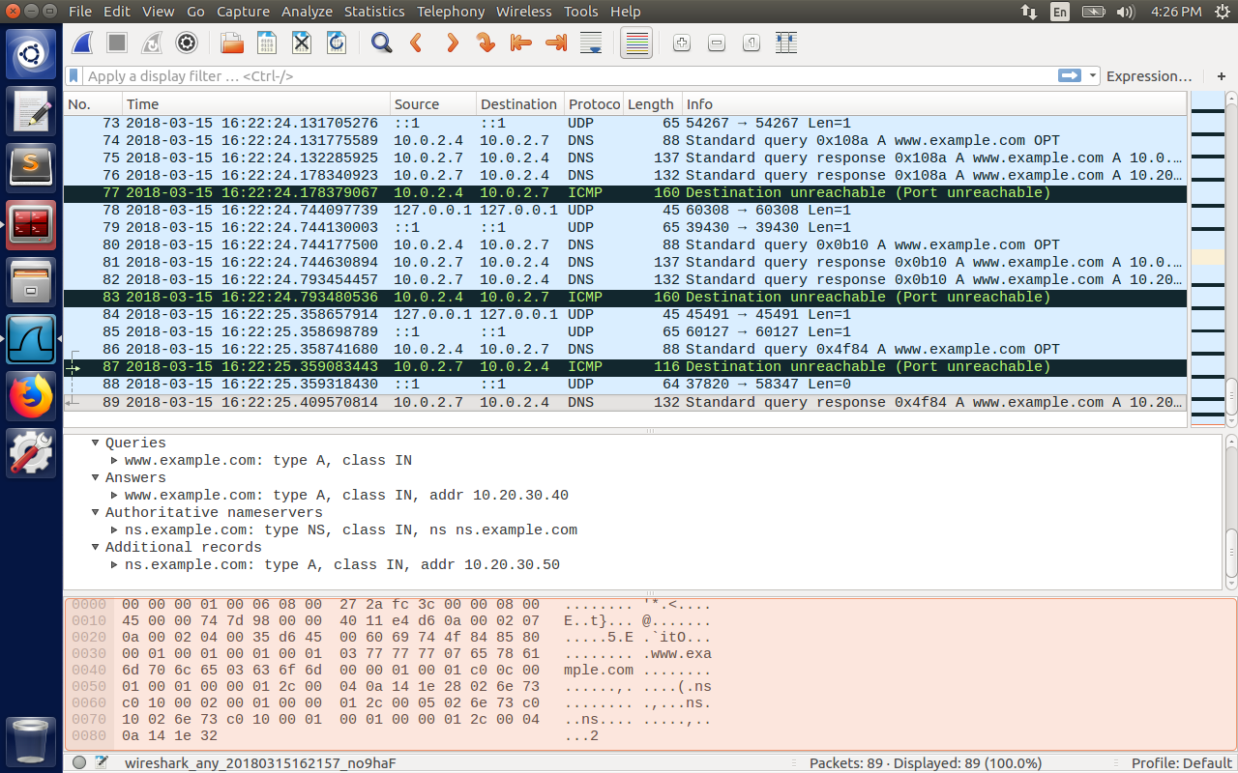

**3.3 Task 3: DNS Server Cache Poisoning**

There is a better approach of targeting the DNS server, instead of the user’s machine. If the host name is not within our domain, the DNS server, it will ask the other DNS servers to get it resolved. But before sending the request, it checks its local cache. If the answer is not present, it will send out request and store the answer in cache, so that the requests don’t have to again wait for answers. In this attack, the attacker will spoof the reply to the local DNS server, and the cache will be poisoned for a TTL field. Before the attack, we will first clear the cache on the DNS server.

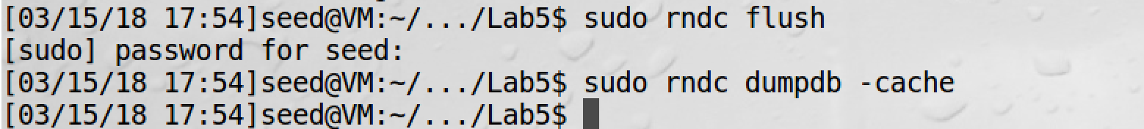

Here the command we give from the attacker machine is as below.

Sudo netwox 105 –hostname www.randomsite.edu --hostnameip “1.2.3.4” –authns “ns.randomsite.edu” –authnsip “1.2.3.5” –device “enp0s3” --ttl 300 –filter “src host 10.0.2.7”

--spoofip raw

Here the filter is set to DNS server (the IP of DNS server in our case is 10.0.2.7), since the attack is on the server side.

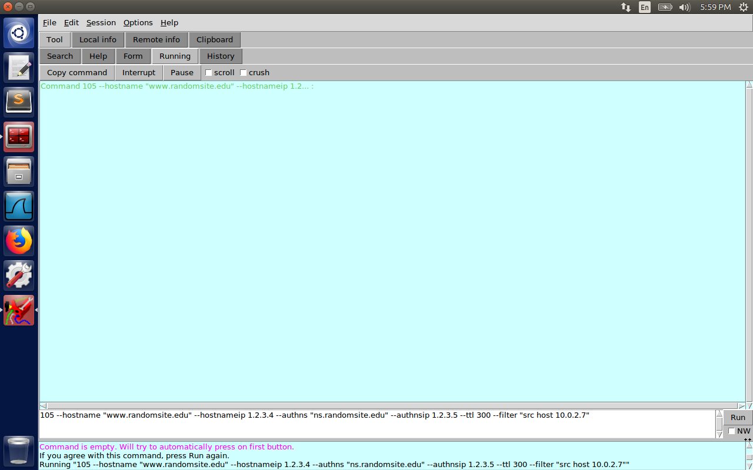

Now the attacker is running the command and waiting for the server to make the request to [www.randomsite.edu](http://www.randomsite.edu) and send the spoofed reply as below captured on the client side.

Please observe the spoofed entry number 4 in the screenshot below with the reply answer as 1.2.3.4 to the client.

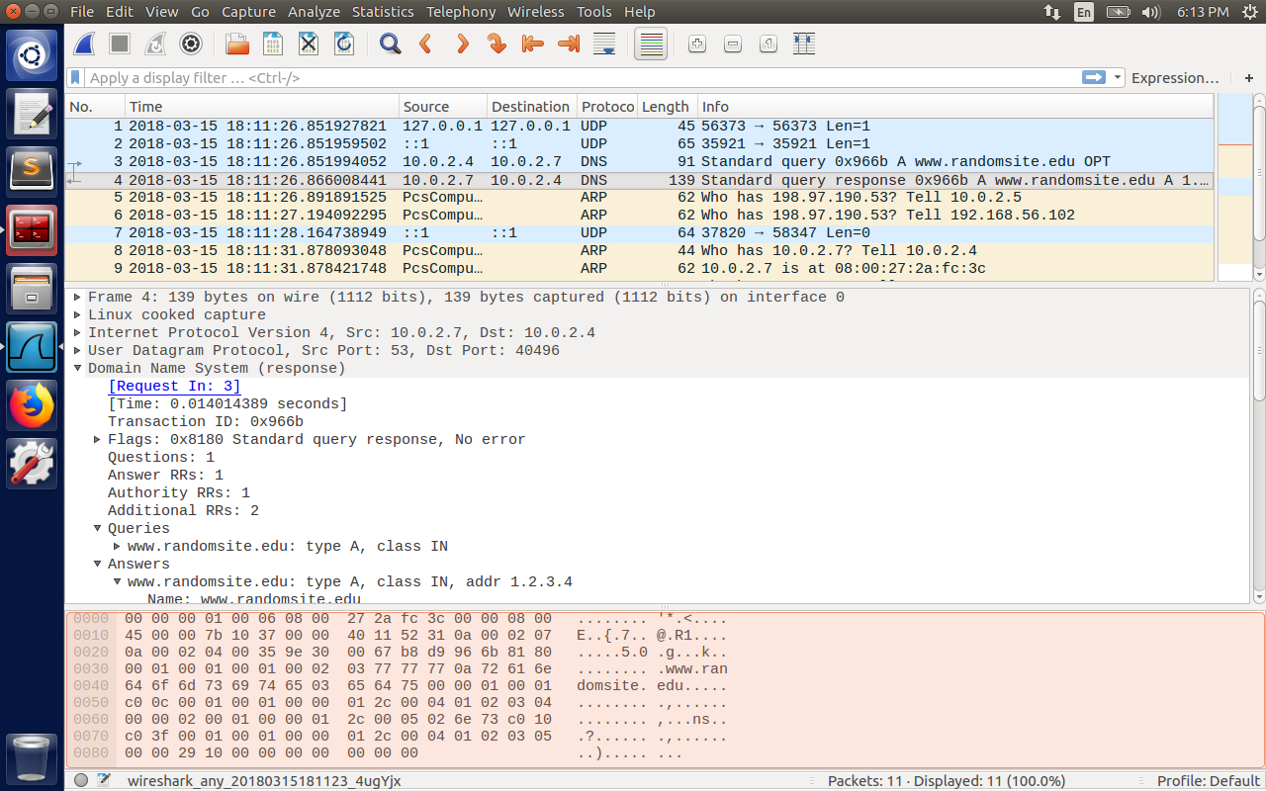

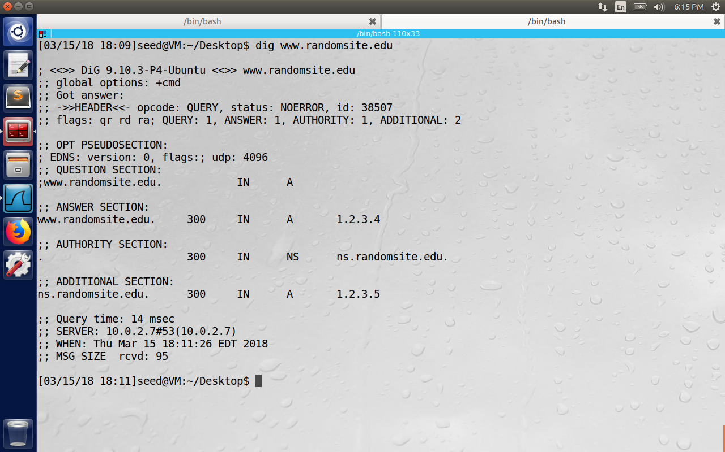

To show the DNS server cache is poisoned, we inspect the dump.db file and observe that it is poisoned with the spoofed reply highlighted in the image below.

